FOSS WATERWAY Location
Driving Directions to 705 Dock Street:
- From I-5, take the City Center/Tacoma Dome exit #133.
- Merge onto I-705 and follow the signs for Schuster Parkway.
- After you exit to Schuster Parkway, you will turn right at the light (4th Street Bridge).
- After crossing the bridge, the road turns to the south again and becomes Dock Street.
Free parking for Seaport guests is available in the small parking lot directly adjacent to the Seaport building. A larger pay lot is located north of the Seaport if our spaces are full. Both lots are monitored. There is additional free street parking adjacent to the pay lot.
Download a map with directions
Link to map and directions printer version PDF
Link to Foss Waterway Seaport on Google Maps

Driving Directions to our trailer parking at 459-A East 15th Street:
- From I-5, take the City Center/Tacoma Dome exit #133.
- Keep right at the fork in the ramp.
- Turn right onto E 26th St.
- Take the 2nd left onto E. D St.
- E. D St. becomes E. 15th St.
- 459-A East 15th Street is on the left.

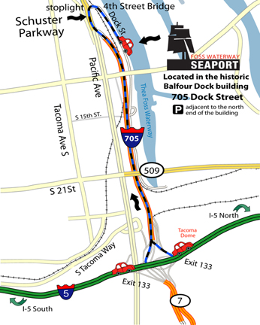

Water access to Foss Waterway Seaport secured dock A:

Decimal Degrees (WGS84)
Latitude | Longitude
47.257662 | -122.43603
Degrees, Minutes & Seconds
Latitude | Longitude
N47 15 27 | W122 26 09
GPS
Latitude | Longitude
N 47 15.460 | W 122 26.162
UTM
 | X | Y
10N | 542670 | 5233952

